Study course: Software Engineering
Trajectory: internship / graduation

Grass Monitoring

For our clients we are looking for a Software Engineering intern or graduate student who likes the challenge of automating repetitive and labor intensive work. The two parties involved are busy with maintenance of golf courses and the development of new grass varieties. The composition of grass determines the quality of a golf course or grass in general. We want to investigate whether it is possible to develop an automated system that can determine the grass varieties in photographs by means of deep learning. The result will be a deep learning model.

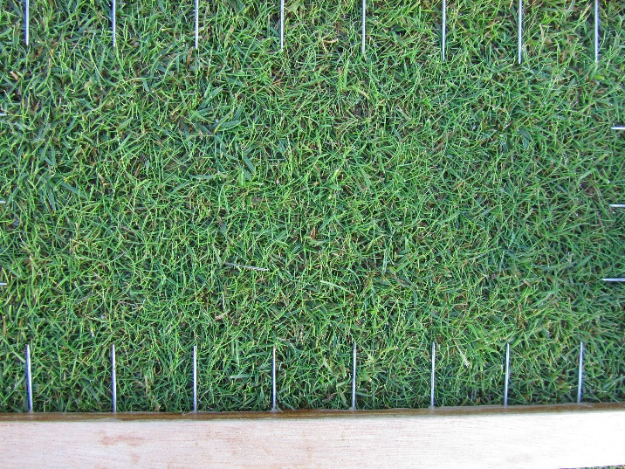 | 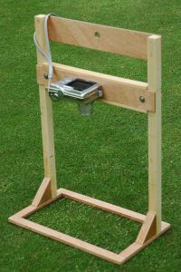

Photo: the current way of grass monitoring and variety determination by means of the "Digidet" (right)

Based on the methodical design process you will start with a technical investigation about which requirements and which possibilities there are to replace the current way of analysis (see pictures above). Definitions of the desired grass classes are made in close consultation with the customer. Subsequently, a dataset needs to be gathered. Together with us you will determine the most suitable way to label the pictures and classify/detect them by means of deep learning.

Graduation is done at GreenTechLab, which you also supervise. GreenTechLab is a technical Expertise Centre with a focus on the synergy between the agro-food sector and technology. This Centre of Expertise has a far-reaching partnership with Fontys Hogeschool Techniek en Logistiek in Venlo (FHTenL), where they are also located. The team consists of 10 engineers (5 FTE) with a background in Mechatronics, Mechanical Engineering, Process Engineering and Computer Science.

